**Git Practical**

**AIM : Tasks**

1. **Import this project to your local system**
2. **Create a new project in your local GitHub repository and export your code in to that repository**
3. **Now work on your local GitHub repository**
4. **Run the server JS file in node JS and check if the application is running or not.**

**Step 1: import the project in your local**

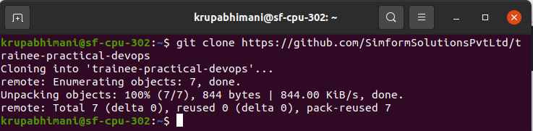

**Step 2: Create a new project in your local GitHub repository and export your code in to that repository**

Create repository in github

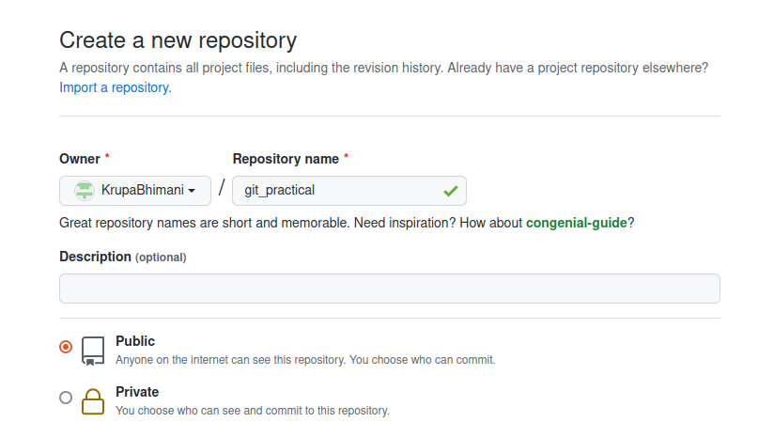

Initialize new project in your local



Link your remote repository to your local one.



**Step 3: Now work on your local GitHub repository**

Copy the whole repository in your local

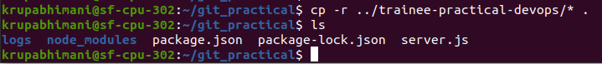

Now let’s add this files in github perform add and commit operation

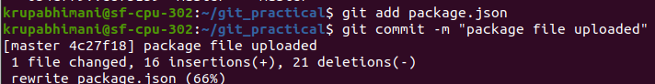

Push the changes into repository

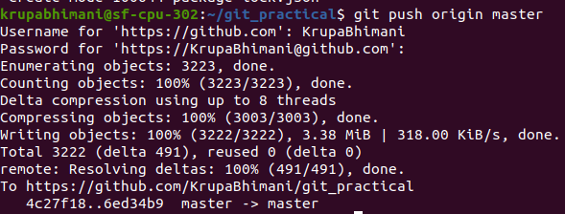

You can see the files are added in repository

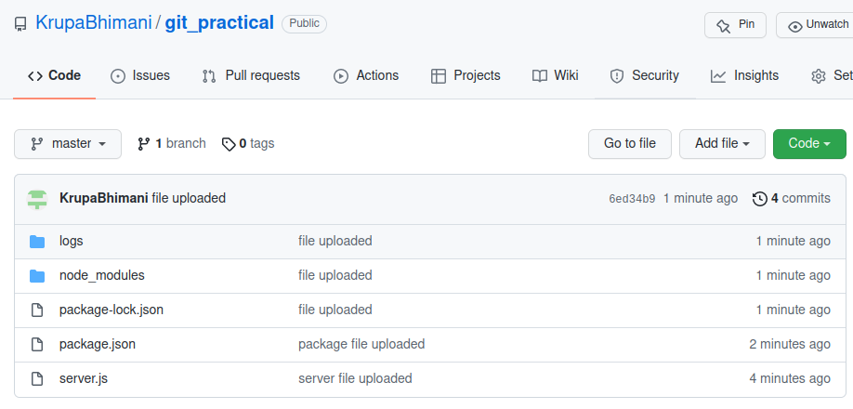

Check commit history in one line

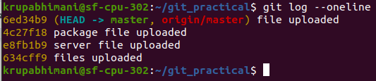

**Extra Tasks:**

**How to delete commits from local repository and reflect it to remote repository**

**Let’s delete two commits in the local repository.**

* Git reset: it is used when you want to reset the commits or change history of it.
  + Git reset --soft : it will move the specific commit to staging area (useful when you want to add more changes before committing)
  + Git reset --mixed: default reset option - moves the commit to working directory
  + Git reset --hard: it moves to the trash. Used when you mess around making changes and decide that you don't want anything to keep.

Here we will use hard reset for deleting commit and move it to trash.

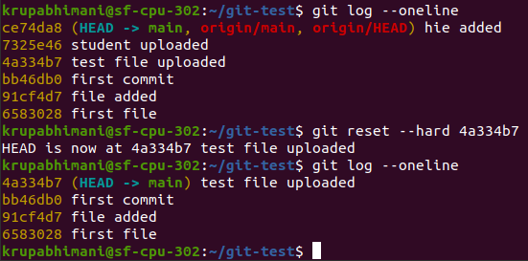

Git push --force : forcefully push

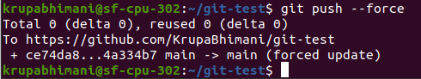

Creating branch:

Git checkout -b command is used to creating a branch in switch to that branch



Commit to that branch

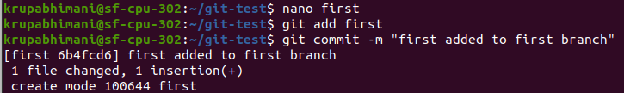

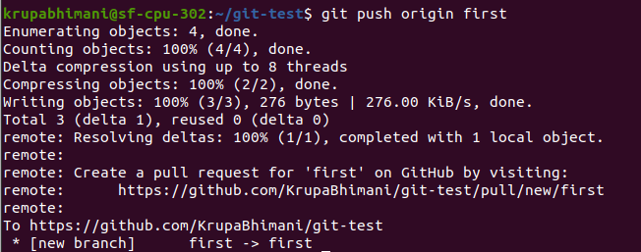

**Git rebase**

* Git rebase [branch_name] : it will detach a particular branch from the base of two branches and joints after the branch you have specified in command.

(it will create new commits on the branch and old commits will be garbage collected by git)

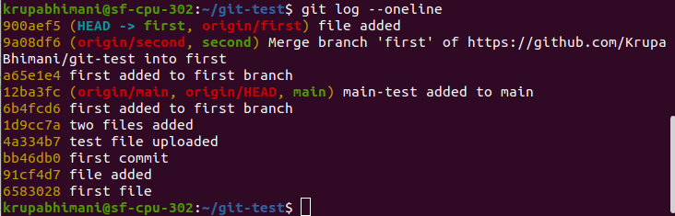

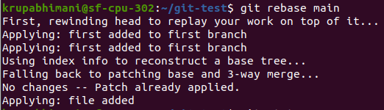

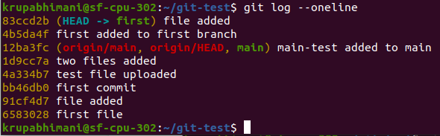

Git revert:

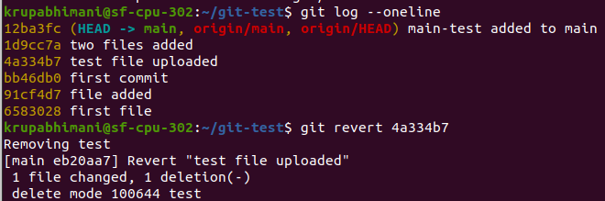

**Step 4: Run the server JS file in node JS and check if the application is running or not.**

Now let’s check if the app is running or not

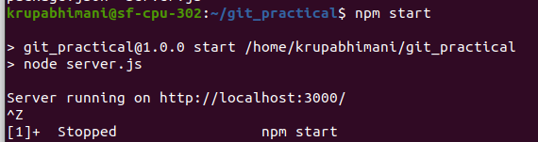

As we run this app we get error

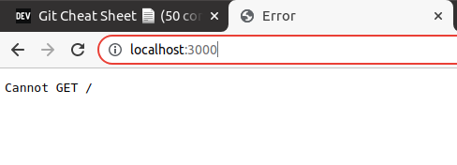

As you can see in this app.get(‘/healthcheck’) location

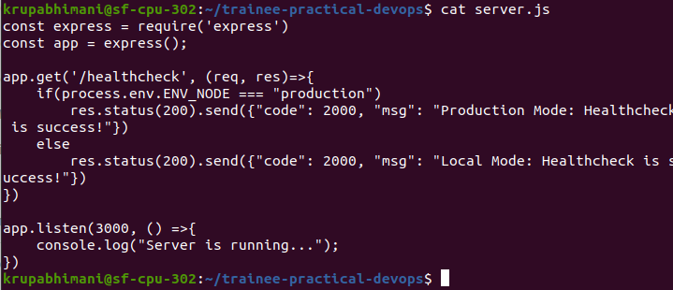

After writing /health check in browser you can see app is running so there is no issues in app

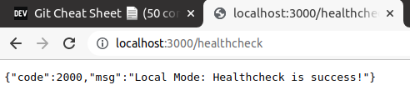

Now stop the app

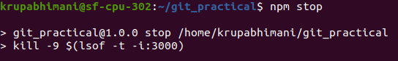

Server.js file

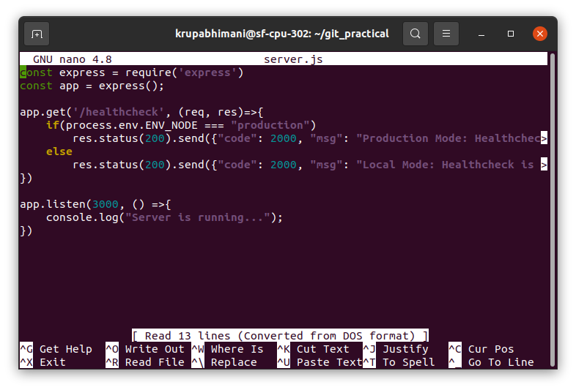

Package.json file

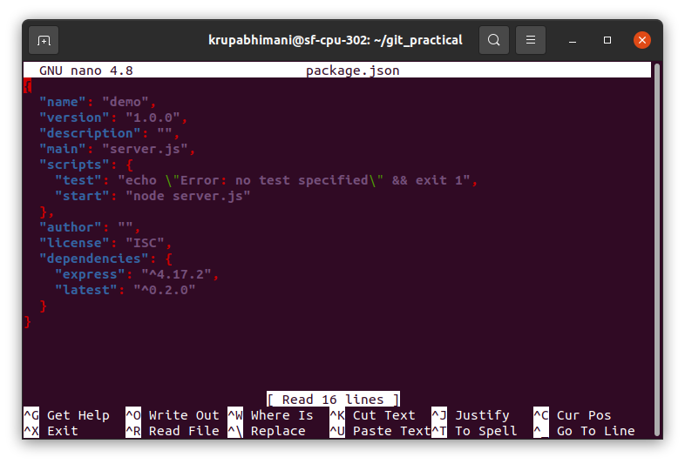

As we see there is no error in this application the application is running fine.